This document outlines how to build, install, and use the TRU Eng Planner App. It includes step-by-step tutorials and links to useful external sources.

## Table of Contents

Table of Contents 1

Build 2

Install 4

Method 1 4

Method 2 6

Use 6

Before Use 6

On Start-Up 7

Quick View 8

View My Plan 9

Pass Fail Editor 10

Manual Schedule Change 11

Make A Plan 12

Admin 14

## 

## Build

**Step1:** Building the application from the source code can be done easily by using Android Studio. To get Android Studio follow the tutorial given here: <https://developer.android.com/studio/install>. After installing android studio, you will see the screen seen in the figure below.

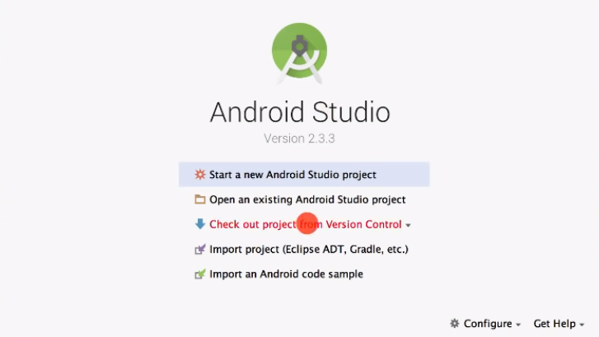

**Step2:** Click on “Check out project from Version Control”. Afterwards click on “Git” as seen in the figure below.

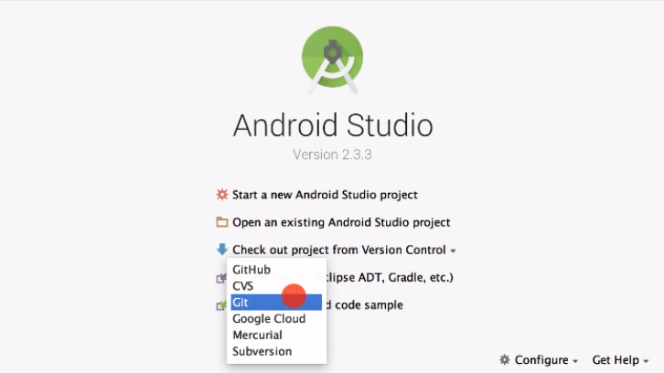

**Step3:** After clicking “Git” the dialogue box seen in the figure below will appear. Enter the URL for the git repository ( <https://github.com/kbef/group1apk.git> ), Enter the path you want to save the repository, and click on “clone”.

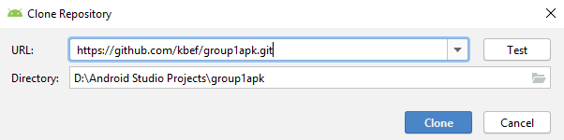

**Step4:** After the repository clones successfully and the project is open, click on the “Sync Project With Gradle Files” button located on the top left corner as seen below.

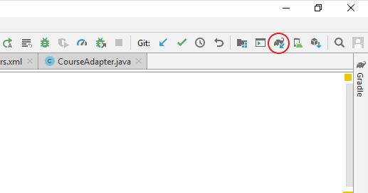

**Step5:** Finally, click the build button as seen in the figure below.



For an alternative way to build the project check the link here: <https://source.android.com/setup/build/building>

## Install

Follow one of the two methods listed below to install the app on your device. Before following the methods, do all the steps except the final step in the Build section above.

### Method 1

**Step1:** On the toolbar click on *Build > BuildBundle(s) / APK(s) > Build APK(s).* As seen below.

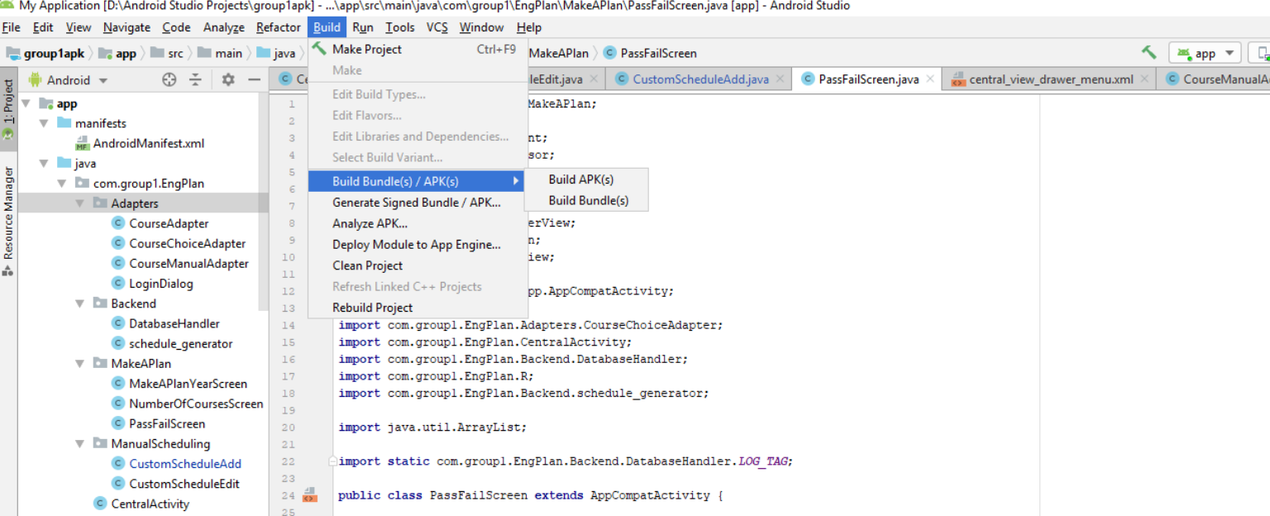

**Step2:** Find the location of the APK file by selecting “locate” on the notification shown after the APK file is made or by following the path group1apk\app\build\outputs\apk\debug from the project directory.

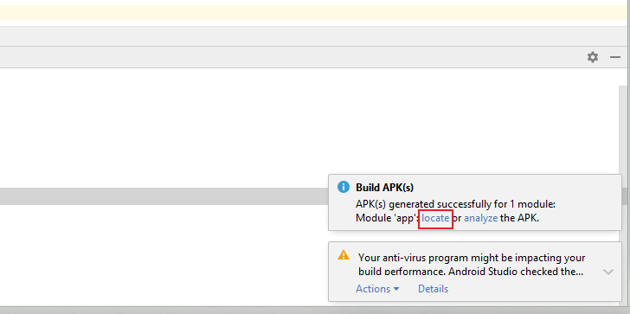

**Step3:** After finding the “app-debug” file as seen below, plug the device into the computer and copy the file to a folder on your device as seen in the second figure below.

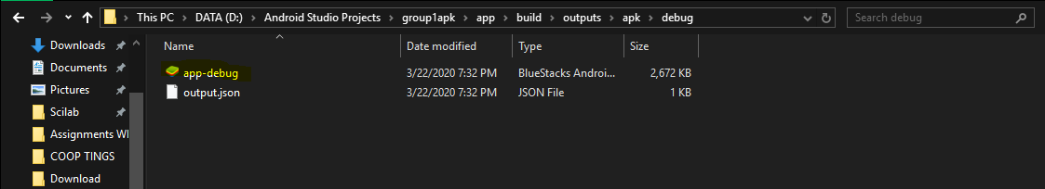

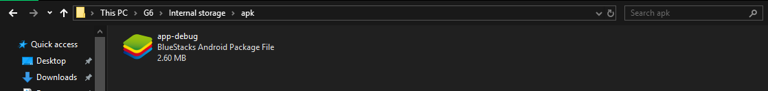

**Step4:** Open the file manager on your phone and navigate to the folder where you saved the “app-debug” file.

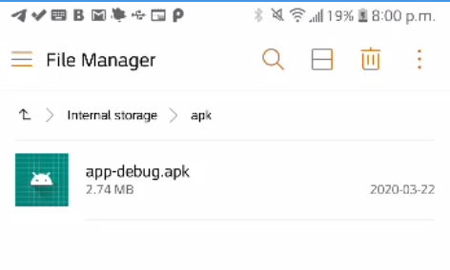

Step5: Click on the “app-debug” file and click install.

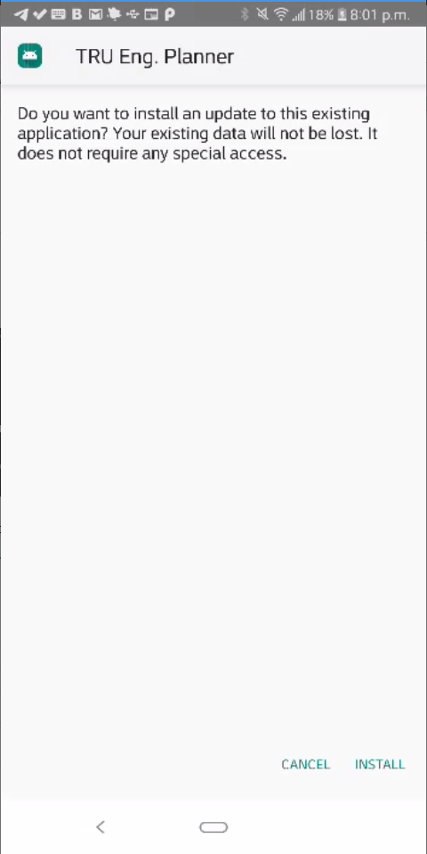

### Method 2

**Step1**: Enable USB debugging in Settings > Developer Options > USB Debugging. NOTE: if you don’t have Developer Options, follow the link here: <https://developer.android.com/studio/debug/dev-options> and follow the steps to enable it.

**Step2:** Plug your device into the computer.

**Step3:** In android studio, go to your list of devices and find your device as seen in the figure below.

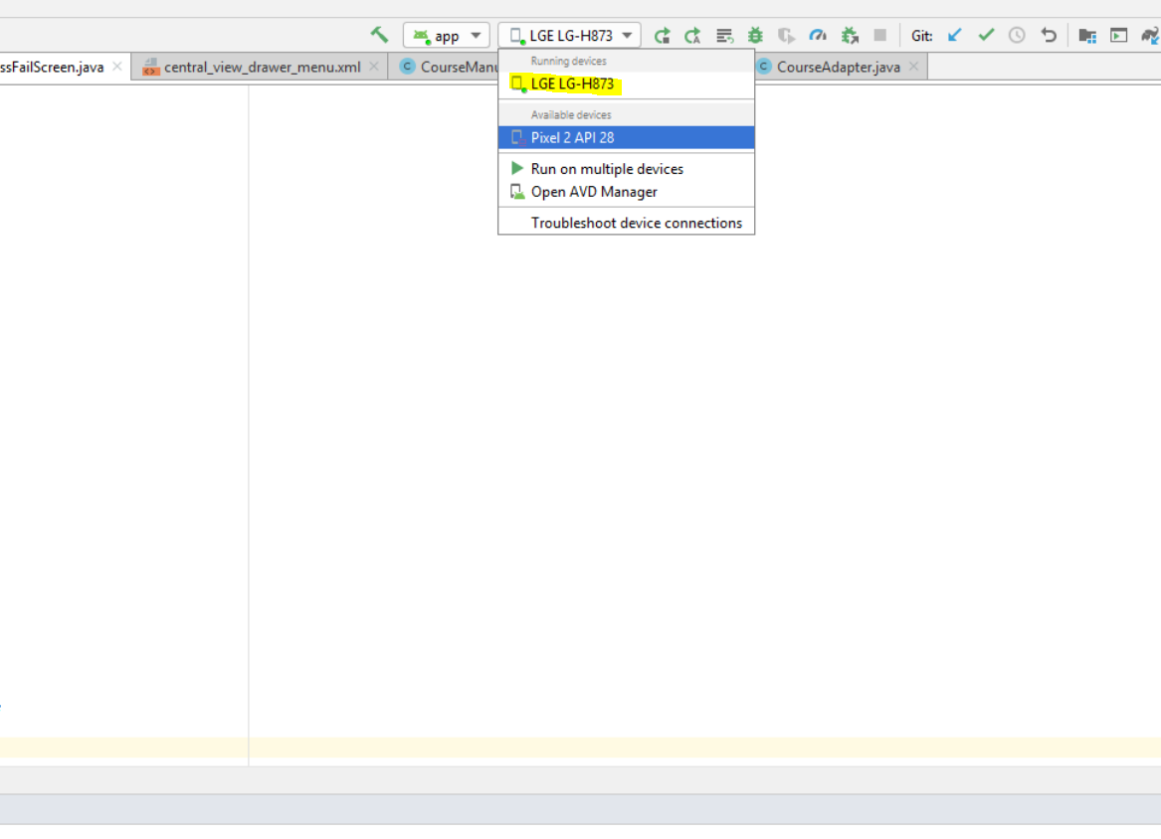

**Step4:** Select your device from the list.

**Step5:** Press the run button (circled in red) as seen in the figure below.

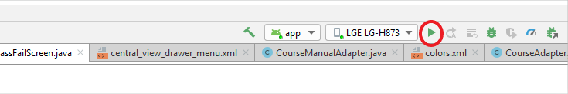

## Use

### Before Use

Before using the TRU Eng Planner app for the first time, the user must allow storage permissions to make use of the downloadable and uploadable database feature. This can be done through accessing the application settings and turning on Storage permissions.

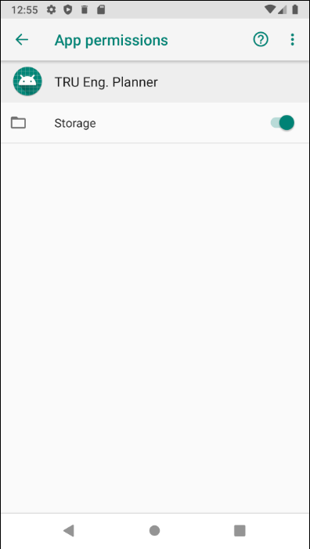

### On Start-Up

The main screen of the app contains four buttons: Admin, Make A Plan, Quick View, and View My Plan. All application features can be accessed from this screen.

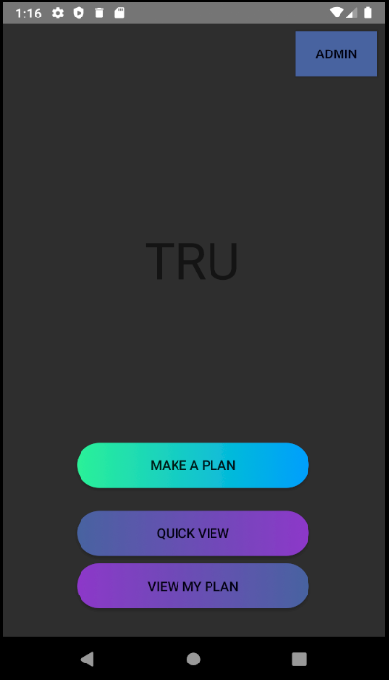

### Quick View

Quick View allows the user to see the schedule made up in the “ideal” way set by Thompson Rivers University. What is meant by “ideal” is that each course is placed into semesters in such a way that all prerequisites are satisfied and to have the degree finished by the end of Winter 5.

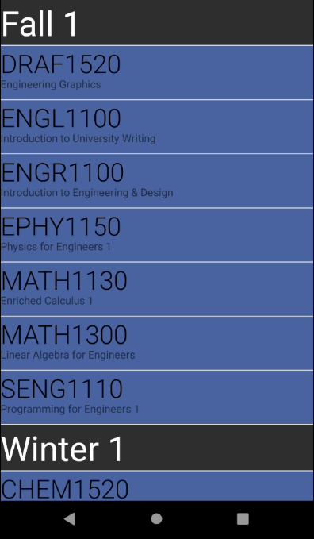

The user can scroll through to see each course. Each course listed is clickable, and if clicked, displays the details of the course. The details include the course number, course name, the semester(s) that it is offered on campus, the pre-requisites, and the post-requisites.

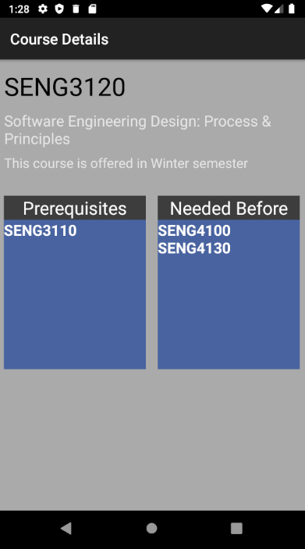

### View My Plan

When the user clicks on View My Plan, the saved schedule will be displayed for the user. If the user has not made a plan yet, the schedule displayed will be the same as in Quick View. If a custom schedule has been made, this is displayed for the user.

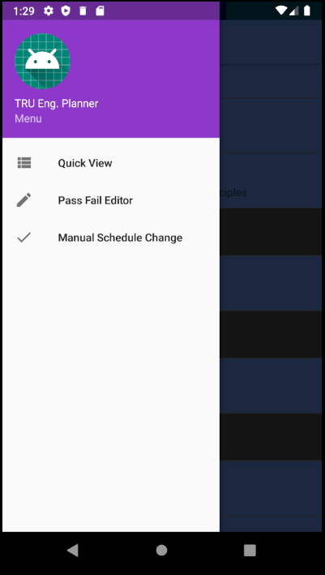

From this menu, the user is able to see the “ideal” schedule through the Quick View option, the user can mark more courses as passed for the schedule to be regenerated through the Pass Fail Editor button, and the user can make manual changes to their schedule with the Manual Schedule Change button.

#### Pass Fail Editor

The Pass Fail Editor displays a comprehensive list of all courses in the degree program. The user should select the courses that the user has taken and passed (or if scheduling for the next semester, select the courses that are presumed to be passed by the start of the next semester). After all courses have been properly marked, click on the Next button.

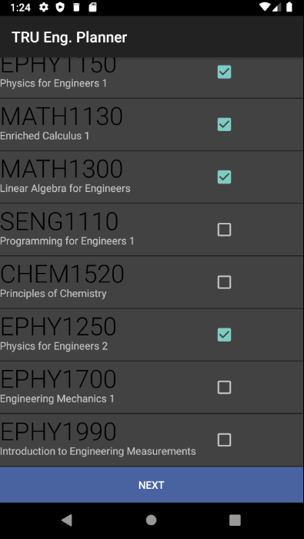

#### Manual Schedule Change

After clicking on the Manual Schedule Change button, the user’s saved schedule is displayed in full on the screen, with a plus sign in the right corner of each semester heading.

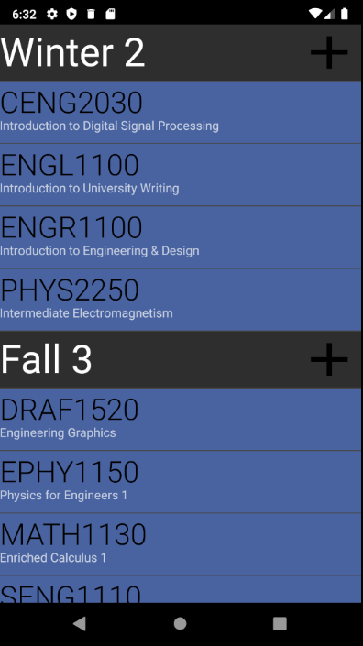

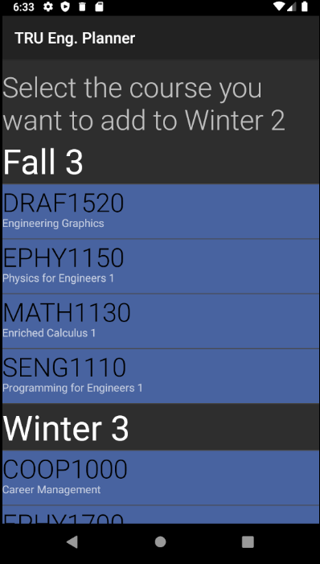

When the user clicks on a plus button, a header is displayed to notify them of what semester they are changing, and they are shown their saved schedule without the semester that they are editing. The user can click any course and the app will notify them if the course is not offered in that semester. The app will also notify the user if there is a prerequisite or post requisite conflict created by the move. Once the user confirms the change, the saved schedule will be updated.

**Note: the manual changes can create an invalid schedule, so it is imperative that if the user has chosen to disregard a prerequisite that they have permission from the university**

Any course that has been manually scheduled will remain in that semester even after more courses have been marked as passed and the schedule regenerates.

### Make A Plan

Make A Plan is how the user is able to create a valid schedule based on how many courses per semester they want to take, and which courses they have already taken.

After the user clicks on the Make A Plan button, they will be prompted to select what year of studies they are in and which semester they are entering (or which semester the plan should start at). The user then has the option of choosing how many courses per semester they wish to take.

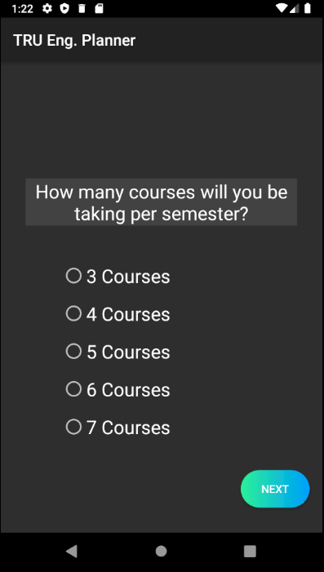

Once the user has chosen how many courses to take per semester, the user should mark their passed courses on the Pass Fail Editor screen.

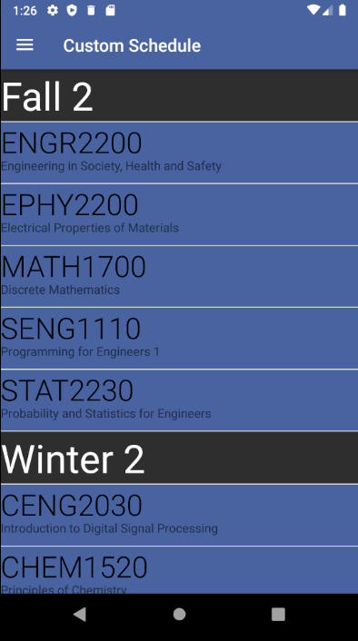

The next screen displays the valid schedule that matches what the user has inputted. This is the same as the screen displayed if View My Plan is clicked. Each course is clickable and displays the same information as in Quick View.

### Admin

The Admin button is how the user can upload and download the database through text files.

**Note: this should not be done unless the university has changed the course schedule and only valid course information should be uploaded to avoid unexpected errors.**

When the Admin button is clicked, a pop-up appears where the user should enter the credentials or cancel the action.

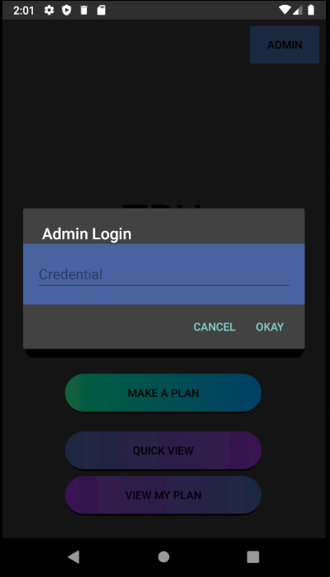

If an incorrect password is entered, a message will appear on the screen and the pop-up will close. A correct password takes the user to the Update Database screen.

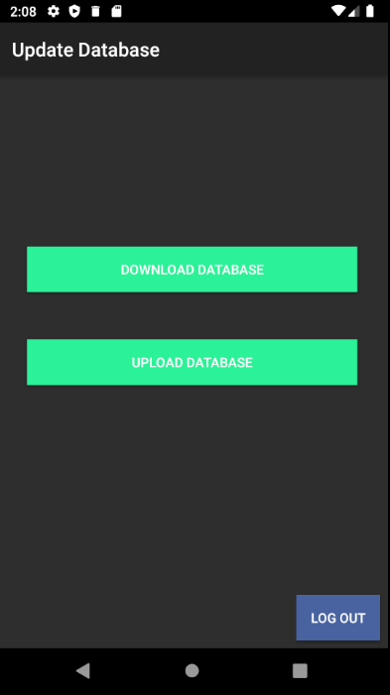

The two buttons correspond to uploading and downloading a database. If the Download Database button is selected, a message saying “Downloaded!” appears and a text file called downloadedDB.txt can be found in the user’s files under Downloads.

To upload a database, a text file named uoloadedDB.txt should be created in the Downloads folder in the following format: all fields must be separated by a vertical line, the fields should be in the order of course id, course name, semester offered (as “W”, “B”, or “F”), ideal semester to take the course (as “W” or “F” followed by an integer number from 1 to 5 representing the year, prerequisite 1, prerequisite 2, post requisite 1, post requisite 2, post requisite 3, post requisite 4. If any prerequisite or post requisite does not exist, use lower case “null” in its place. Some samples are given as follows:

EPHY1990 | Introduction to Engineering Measurements | W | W1 | EPHY1150 | MATH1130 | null | null | null | null |

SENG1210 | Programming 1 for Engineers | F | F1 | null | null | SENG1250 | null | null | null | null |

If it is not in this format, an error message will appear. If the file is not in the correct directory, an error message will appear. If it is in the correct format and works, another pop-up will appear, letting the user know that the download was successful and that they need to rebuild their custom schedule.

**Note: the program checks for incorrect syntax of the file, not for the validity entered values**

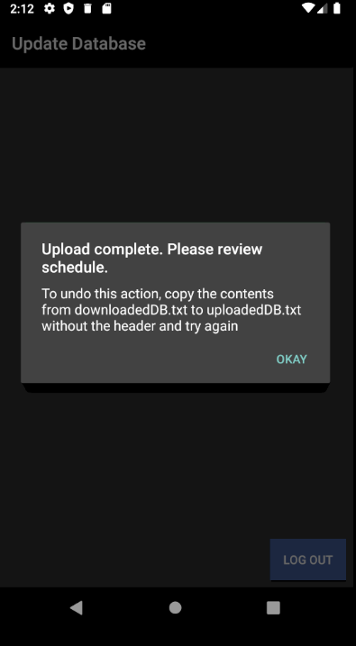

In case the user wants to undo this action, a new downloadedDB.txt was created before uploading the new database. The user should open the text file and copy the contents without the header into an unloadedDB.txt file and redo the upload process.

The only way out of the Update Database screen is to use the Log Out button in the bottom corner.